Week 6: 4 May – 8 May
Geography- Topic: Physical features of South Africa

- Write the date and heading:
5 May 2020 Activity 10: Draw an island with mountains and rivers (pg36)
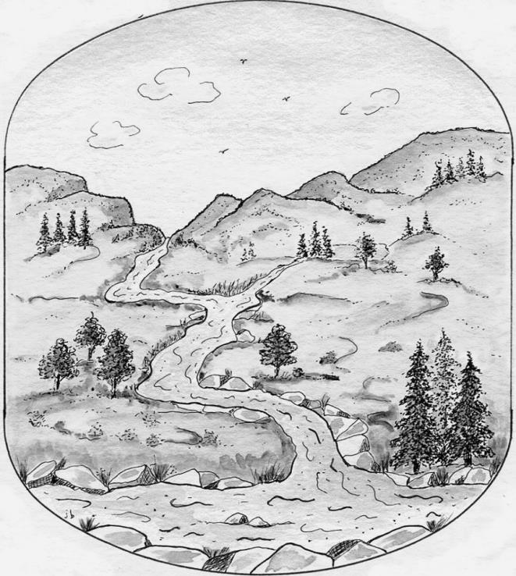
- Discuss question 1 with your parents.
- Use an entire A4 page in your workbook to complete question 2.
- Use the figure on the right as inspiration for your own island design.

Physical features and human activities
Links between physical features, where people live and what they do:
- Physical features have a lot to do with where people live. For example, it is difficult to build a settlement on a steep or rock mountain slope. Flat or gently sloping areas are easier to build on.
- Human activities – the things that people do, for example: working, going to school, or fishing.
- Features of an area influence the kind of human activities that can take place. For example, crops can be grown in fertile areas like valleys.
- Read the information on pg37-39 about how features of an area influence the kind of human activities that can take place.
- Write the date and heading:
6 May 2020 Activity 11: Link physical features to human activities (pg39)
- Use the pictures and information on pg37-39 to complete this activity.
- Redraw the table in your workbook for question 1.
Picture number | Physical Feature | Human activities
1 | Hills | Looking after cattle.
2 | Valley | Growing mealies/crops
- Complete the rest of the table. Number 1-8. Use the pictures on Page 37, 38 and 39.
- Question 2 is part of question 1.
- Question 3 you need to answer in full sentences.

