Social Science – Grade 5 (Catch-up Programme)
Week 1: 30 March – 3 April
Geography
Topic: Physical features of South Africa (P24)
Introduction
- South Africa is on the southern end of Africa.
- It has high, low, flat and hilly places.
- Rivers flow from mountains.
- Rivers flow from a high area down to the sea.
- South Africa’s coastline meets with both the Atlantic and Indian
Ocean.
- Not all our provinces have a coastline.
- All provinces have rivers and other physical features.
Activity 1: (No need to write this activity in your books, only reading)
- Only need to read the activity. Use the photograph on P24 to help.
- Explain to Mom or Dad in what ways could people use the water from the river.
- What other activities are possible for people who live in this settlement? Use some of the following ideas.
- Sea: surfing, sailing, fishing
- Work: running shops, selling things.

South Africa from above (physical map) P26
High plateaus are inland and away from the sea. Much of the Free State is on the Highveld plateau.
The low coastal plains are mainly in Northern KwaZulu-Natal.
- Start in your workbook and write Term 2 over 3 of 4 lines.
- Write the date ( 31 March 2020). Heading: South Africa from above (P26,27) Activity 2
- Write the following NEW WORDS down with their meanings in your book. 1. Physical features 2. Plateau 3. Coast
- Coastal plain 5. Escarpment.
- Draw the picture underneath in your book and label it.

- Read through all the information on page 26 and 27 before you start with activity 2.
- Use the Map on P26 and the picture and information on P27 to help.
- Complete Activity 2 in your book.

Social Science – Grade 5 (Catch-up Programme)
Week 1: 30 March – 3 April
History
Topic: The first farmers in southern Africa (P110)
Introduction
- First people to live in South Africa – The San.
- Khoikoi herders arrived after the San.
- 250 AD new groups of African people slowly moved south and settled in Southern Africa.
- AD – anno domini (Latin words that mean in the year of Our Lord)
- African farmers grew crops and kept cattle.
- They lived in settled villages and spoke Bantu languages.

When, why and where the first African farmers settled in Southern Africa.
AD – dates are counted forwards from the date of Christ’s birth (AC – After Christ)
BC – dates are counted backwards from the date of Christ’s birth. (Before Christ)
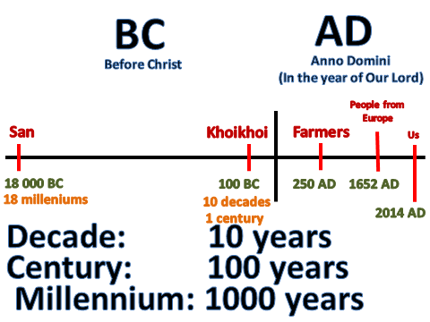
2020 AD

- Read all the information on P112 and 113.
- Write Term 2 over 3 or 4 lines in your book.
- Activity 1 only read.
- Iron Age: Farmers made tools of iron. (Refer to definition in textbook)
- Crops needed summer rainfall. They settled on land that had enough rainfall in summer.

- Write the date 2 April 2020 Heading: The Fisrt African Farmers in Southern Africa P112,113)
- Write the following NEW WORDS with their meanings in your book. 1. Farmers 2. Iron Age 3. Domestic 4. Crops
- Also copy the meanings of year, decade, century and millennium in your book.
- Complete Activity 2 (P113) in your books.

