Geography- Topic: Physical Features of South Africa
Revision: Week 11 (8 June 2020 – 12 June 2020)

- Please print these pages and paste in your book, or write the question with the answer if you cannot print the pages.

Mountains, hills and valleys

Mountains are high areas of land with steep sides. A mountain range is an area that has many mountains. The uKhahlamba-Drakensberg is a mountain range.

Hills are smaller mountains with gentle slopes. Hills may be next to mountain ranges. The low areas in between mountains and hills are valleys.

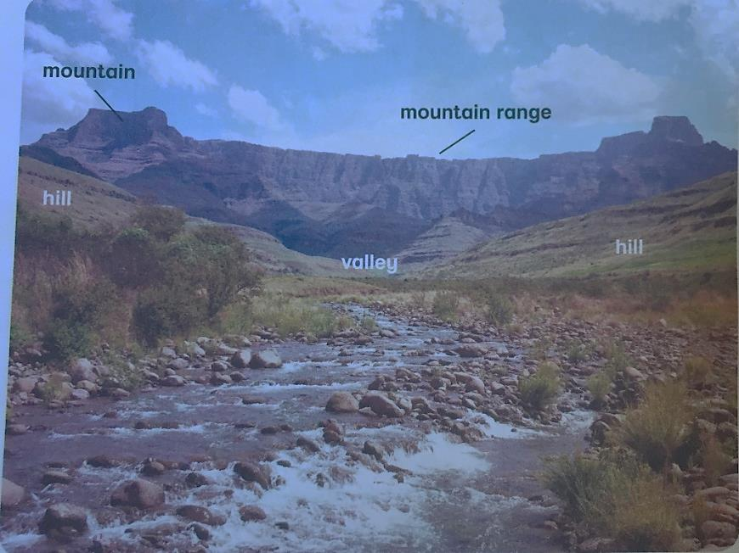

Coastline, capes and bays

The coastline is the narrow strip of land next to the sea. South Africa’s coastline is nearly
3 000 km long. There are different physical features along the coastline.

A cape is a piece of land that sticks out into the sea. Cape Point is one of South Africa’s most famous landmarks.

A bay is an area of sea that is partly surrounded by land. False Bay next to Cape Point is a bay.

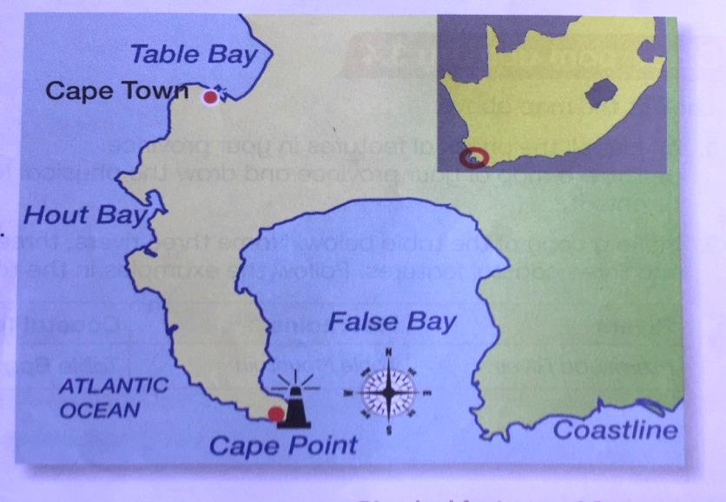

Write the date: 8 June 2020 and the heading Physical features

- Copy the following crossword puzzle or fill the answers in on the paper.

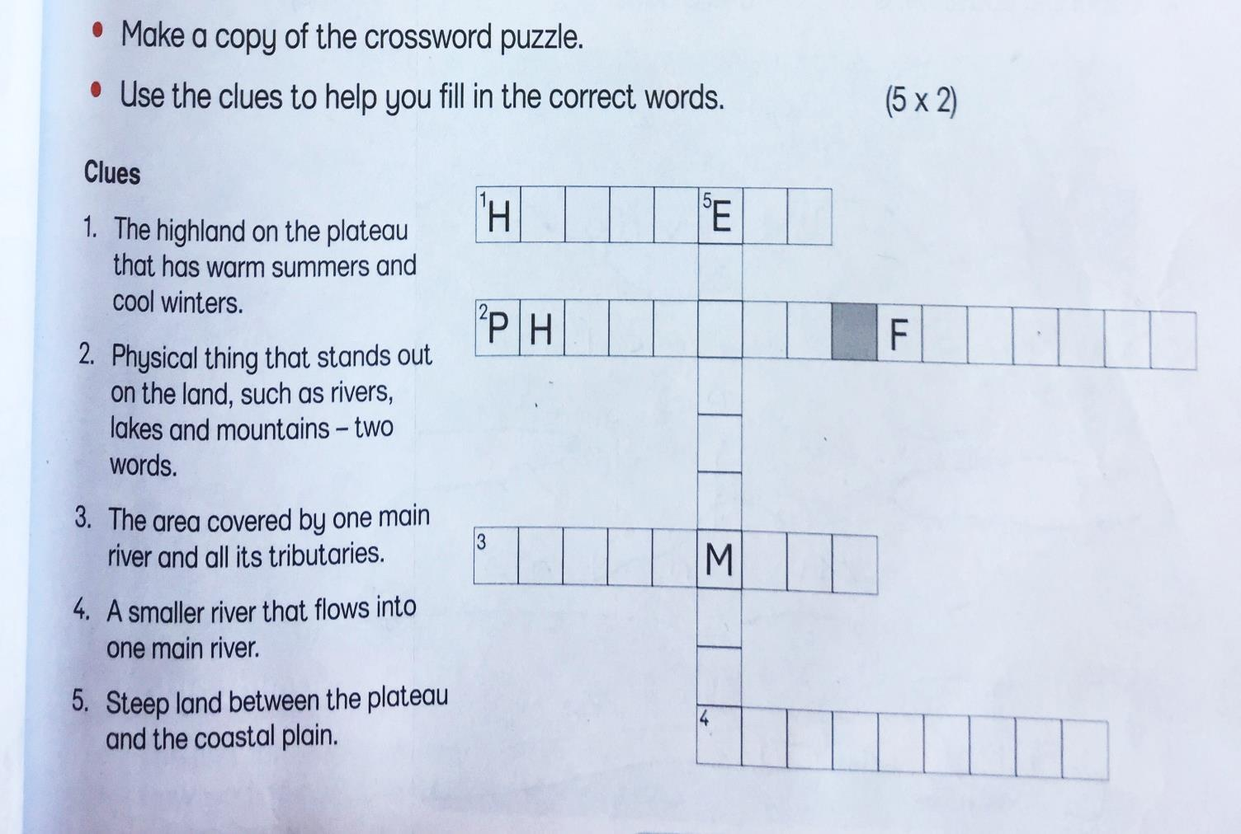

Study the following map and answer the questions.

- Label the map A – F. Use the following keywords to help you.

Robben Island, Table Mountain, the coastline, False Bay, Cape Point, Atlantic Ocean. Also use the map on the previous page to help you.

- In what province are the above physical features?
________________________________________

- How did people change the land on this map?
________________________________________

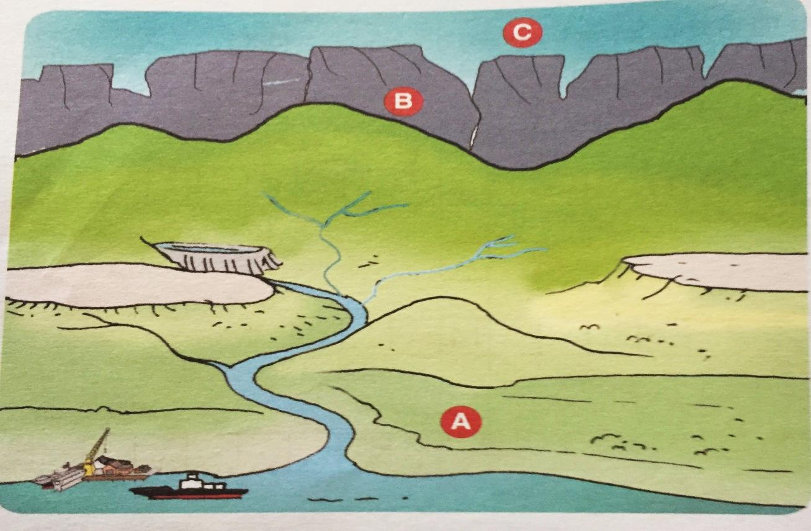

- Look at the picture above. A is your coastal plain, B is your escarpment and C is the plateau. Draw a picture in your book. Use a full page. Add the following in your picture and label it clearly. Please colour your picture.

- Plateau
- Escarpment
- Coastal plain
- Dam
- River
- Tributaries for the river
- Harbour

- Your picture will look very similar to the one above but it will be your own picture with labels. Remember to use lots of colour to make your picture beautiful.

Thank you for all your hard work!

