EDENGLEN PRIMARY SCHOOL
Social Science – Grade 5 (Catch-up Programme)
Week 3: History (13 April – 17 April)
Topic: Social, political and economic structures
Page 118, 119 and 120 in Textbook

Introduction
- In farming communities food and seed are stored.
- People who control these stores may have a lot of power over other people.
- They can become kings, chiefs, headmen or councillors.
- Other people must serve them and be loyal and obedient if they are to share in the food.
- It is necessary to have many rules to keep the peace.
- Each member in the early African societies had a role to play.
- Younger men – hard work on fields, looked after livestock, hunted for food, fought in battles.
- Women and girls – cooked, brewed beer, fetched wood and water, looked after the children, worked the fields, planting, weeding and harvesting.
- Children (Boys) – helped the men with cattle.
- Girls – helped the women in the fields and in the household.
- When a family needed help, they would organise a work party, they would prepare food and beer,
People would come to help with the work and share meals afterwards.

The role of the Chief
- Very important person. It was believed that they were closer than others to the ancestors.
- They looked after their people.
- Kgotla – The Chief’s kgotla was where people from the village met.
- The Kgotla was in the chief’s homestead between the households of his wives and his cattle kraal.
- All the men of the village could attend meetings in the kgotla.
- Older men were leaders who helped the Chief to settle arguments between people.
- The Chief was the wealthiest man in the village with the most cattle.
- Wrongdoers had to appear before his court. If found guilty, they had to pay a fine in the form of cattle.
- The Chief also obtained cattle from raids on other chiefdoms.
- Refer to the picture on Page 119 about the tall stone at Kaditshwene.

Complete Activity 5 in your workbooks.
Write the Date: 13 April 2020 and the Heading: Roles in society Act 5 Page 119
- Complete the NEW WORDS in your book. Copy down the words and meanings of social, political, economic, structure and kgotla.
- Complete Activity 5 after the new words.

Social Science – Grade 5 (Catch-up Programme) - Continue
Week 3: History (13 April – 17 April)
Topic: Cattle were very important
Page 120 in Textbook
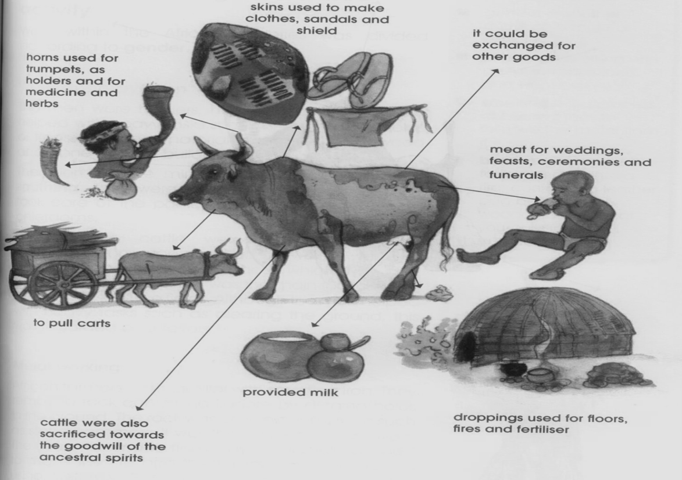
Introduction

- Read the information on Page 120.
- Look at the NEW WORDS.
- Loyal – faithful to
- Lobola – the price of a bride.
- Cattle needed water and food to stay healthy.
- Also refer to the picture above to understand what cattle provided.

Complete Activity 6 in your book.
- Write the Date: 14 April 2020 and the Heading: Cattle were very important

- Write the NEW WORDS with their meanings in your book. ( loyal and lobola).
- Complete Activity 6 question 1-4.

Week 3: 13 April – 17 April
Geography- Topic: Physical features of South Africa
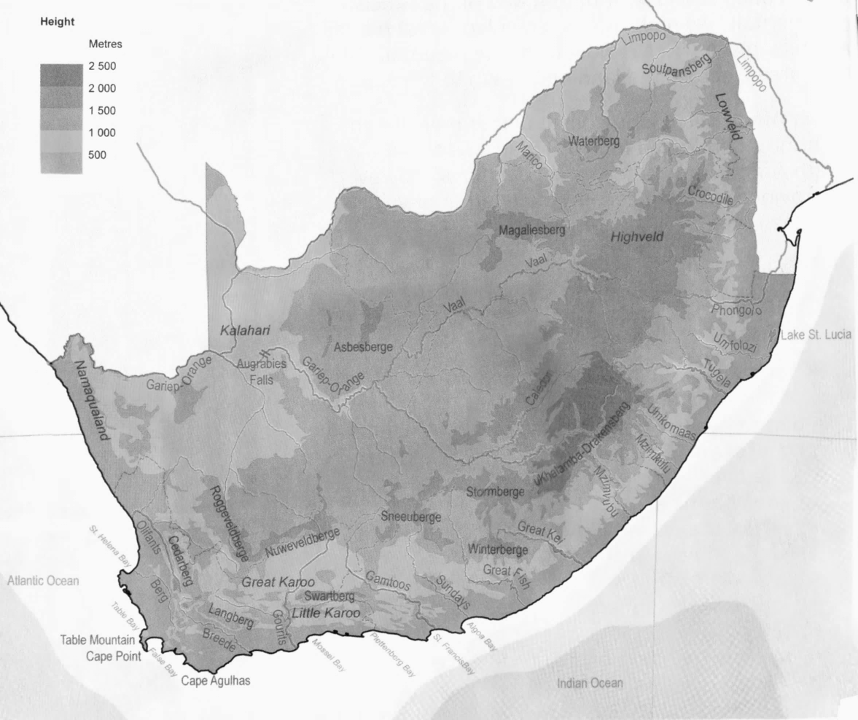

Use the map on pg. 26 to complete the activity below.

- Write the date and heading:
15 April 2020 Activity 5: Use a map to organise information (pg30)

- Redraw and complete the table below in your workbook
Rivers | Mountains | Coastline Features | Areas

2. (Add the answer to question 2 to your table)

Write the date and heading:

16 April 2020 Activity 6: Name physical features in your province (pg. 30)

- Use the map on pg. 26 to complete this activity.
- Complete all questions in your workbook.
- Number all the questions from this activity accordingly.

