Geography- Topic: Physical features of South Africa
Week 9: 25 May 2020 – 29 May 2020
Revision and Extra information
South Africa’s high and low areas
We divide South Africa into three main areas. Each area is a different height above sea level. Remember sea level is the halfway point between high tide and low tide along the coastline. It is the height that the sea touches the land.
The three main areas are:
- Coastal Plain
- Escarpment
- The plateau
Coastal Plain
This is the area near to the coast. The land is quite flat and not very high above sea level. The word plain means flat land.
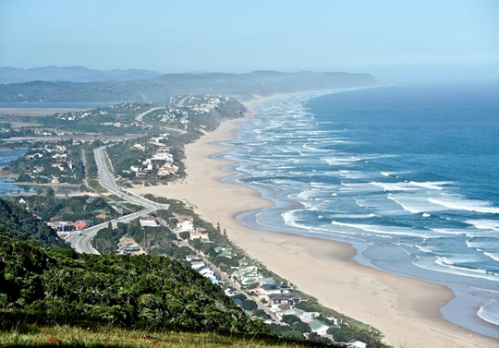
Escarpment
The escarpment is an area of steep slopes. It divides the coastal plain from the plateau. There are high mountains along or near the escarpment.
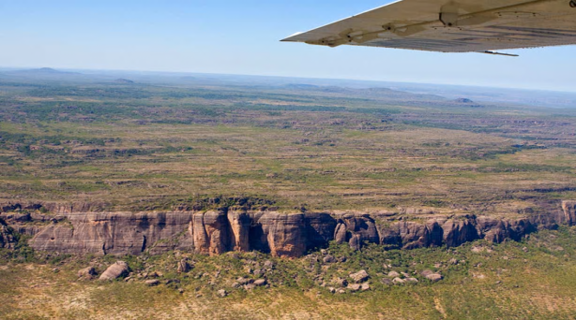
Plateau
A plateau is a large flat area with steep sides. The steep sides are the escarpment. The plateau covers the largest part of South Africa.

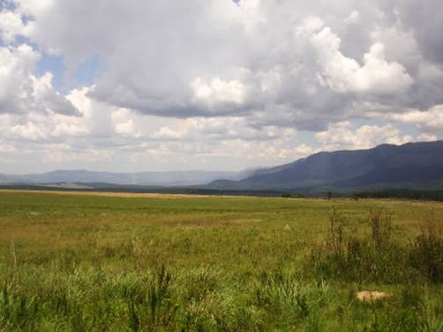

The build of the land across South Africa – High and low land.
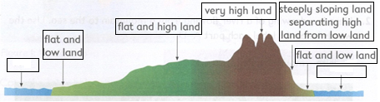
Ocean
Ocean

3
2
1

6
EAST
WEST

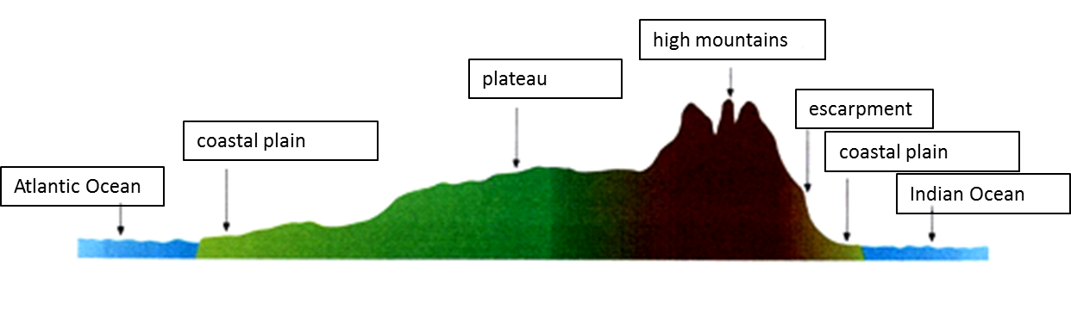
Physical Areas
Highveld, Lowveld, Great Karoo, Little Karoo, Namaqualand, Kalahari.
A map showing South Africa’s coastal plain, escarpment and plateau
Each of these areas is a different height above sea level.
Coastal plain: This is the area near to the coast. The land is quite flat and not very high above sea level. The word ‘plain’ means flat land.

The plateau: This is a large flat area with steep sides. The steep sides are the escarpment. The plateau covers the largest part of South Africa. The plateau is between 1 000m and 2 000m above sea level.

The escarpment: This is an area of steep slopes. The escarpment divides the coastal plain from the plateau. There are high mountains along or near to the escarpment.

Physical Areas
Highveld, Lowveld, Great Karoo, Little Karoo, Namaqualand, Kalahari.
A map dividing South Africa into physical areas
South Africa can be divided into six physical areas. Things that make the six areas different are height, size and rain.
The Highveld is a high lying area over 1 600m high. It is found mostly in the Free State, Gauteng, Mpumalanga and the eastern part of the North West province.
The Lowveld is a lower lying area (about 800m high) found on the eastern part of South Africa.
The Great and Little Karoo are large valleys found between mountain ranges in the Western Cape. The Little Karoo is smaller in size while the Great Karoo is bigger. The Swartberg Mountains separate these two regions.
Namaqualand is well known for its colourful flowers that grow after the winter rainfall. It is found along the west coast near Namibia.
The Kalahari Desert is a large, semi-dry, sandy area.
_____________________________________________________________________________________________
Things that make the six physical areas different are:
- Height
- Size
- Rain
Physical features
Mountains, hills and valleys
Mountains are high areas of land with steep sides. A mountain range is an area that has many mountains. The uKhahlamba-Drakensberg is a mountain range.
Hills are smaller mountains with gentle slopes. Hills may be next to mountain ranges. The low ares in between mountains and hills are valleys.
Rivers
Rivers are channels of fresh water that flow downhill. Most rivers start in high places such as mountain ranges and flow into the sea as well as into lakes and other rivers.
Waterfalls
When rivers flow over a piece of land it makes a waterfall. The Thukela Falls is the second highest waterfall in the world.
Coastlines, capes and bays
The coastline is the narrow strip of land, next to the sea. There are different physical features along the coastline.

A Cape: Is a piece of land that sticks out into the sea. Cape Point is one of South Africa’s most famous landmarks.
A Bay: Is an area of sea that is partly surrounded by land. False Bay next to Cape Point is a bay.

Physical Features in your province - Gauteng
In Gauteng we have the following physical features:
- Crocodile River – part of Marico River
- Braamfonteinspruit – Longest stream in Johannesburg
- Apiesriver – flows through Pretoria
- Plovers Lake – Krugersdorp
- Wilge River – Gauteng
- Hennopsriver – Source in Kempton Park
- Klipriver – Johannesburg South
- Roodeplaatdam – Pretoria
- Zoo Lake – Johannesburg Zoo

Place Names
Many places are given names that describe their physical features.
Sand River – river that is often dry.
Devil’s Tooth – a sharp, pointed rock in the uKhahlamba-Drakensberg Mountains.
Table Mountain – Flat on top in Cape Town.
Table cloth – mountain covered in a cloud.
Hole in the Wall – hole that goes through a huge cliff in the sea off the Eastern Cape.
Robben Island – Many seals on the island. Robben comes from the Dutch word for seal.

Rivers
Where rivers begin and end
A river starts at its source. The place where the river flows into the sea is the river mouth. All rivers flow downhill. Rivers cannot flow uphill. A smaller river that flows into a bigger river is called a tributary.

River Systems
A river system is one main river and all its tributaries. All big rivers have many tributaries.
The area covered by one main river and all its tributaries is called the catchment area.
There is only one river system in a catchment area.
Main Rivers in South Africa
South Africa has two large river systems.
- The Gariep-Orange River System in the centre of the country flows westwards towards the Atlantic Ocean.
- The Limpopo River System in the North east flows in a Northern and Eastern direction into the Indian Ocean.
The rivers in the south of the country do not join up to form any large river systems. They all have their source in the mountains and flow into either the Atlantic – or the Indian Ocean.

Main Rivers | Source | Tributaries | Direction of flow
- Gariep_Orange | Drakensberg in Lesotho | Caledon River  Vaal River  Fish River | West
Olifants River( Limpopo) | Near Bethal (Mpumalanga) | Letaba River  Tubatse River | North
Great Berg | Drakenstein Mountains |  | North
Breede | Dwarsriver, Titus River | Keisers River | West to east
Gourits | Olifants River/Gamka | Groot River
Gamtoos | Groot River,Kouga River | Loerie River,Klein River,Hol River,Grootriver,Kouga River
Sundays | Sneeuberge |  | South
Great Fish | Graaff-Reinet | Groot Brak River  Tarka River  Kap River  Little Fish River | Different directions
Great Kei | Black Kei River  White Kei river
- Tugela | Drakensberg Mountains | Gariep Orange  Vaal River | West to east
Pongola | Utrect in Northern KZN | Bivane River  Mozana River | East then north
Olifants ( Western Cape) | Winterhoek Mountains | Doring River | North-West
- Limpopo | Crocodile River  Marico River | Olifants River  Crocodile River | East
Crocodile | Constantia Kloof | Hennops river  Jukskei River  Elands River | East
- Vaal | Drakensberg | Little vaal river  Klip River  Waterval River | West
Caledon | Drakensberg | Orange River | South west  west

The Journey of a River
Rivers can flow for many kilometres on their journey towards the sea. Rivers that flow strongly can carve deep valleys and gorges into the land. Sometimes a river can drop from a high level to a much lower level. The river forms a waterfall at this place. Large rivers are often joined on their journey to the sea by other rivers. They are called tributaries. Together with the main river called a river system. The area where rain water runs off into a river system is called a catchment area.

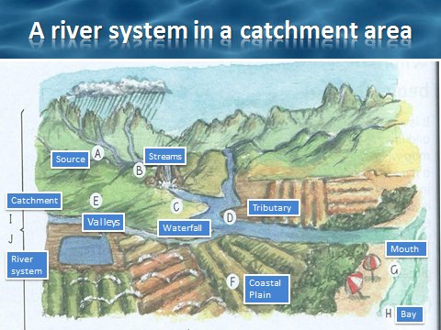
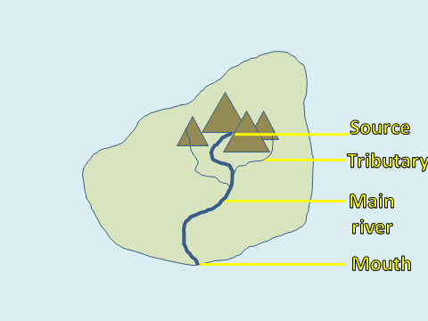
Physical features and human activities
- People and rivers
Everyone needs water. Most of the world’s big cities are near rivers.
- People and mountains
A lot of people in South Africa live in the flat areas and valleys between mountains and the coastal plain. Many people also live on the flat areas of the plateau. Few people live in the mountain areas or on the escarpment.
- People and the coast
There are many reasons people live and work in the coastal plain: Fishing, harbours for ships, land is flat for building, soil is good for farming, big rivers for water and transport.
- How people change the land
- Farmers cut trees to make fields
- Dig into the land to make mines and quarries.
- Build towns and cities that cover the land.
- Roads and railways change the land.
- Build dams on rivers.
Building dams
People build walls over rivers to make dams.This makes a large man-made lake. The ways that dams change the land – dams cover farmland, dams change the flow of rivers, dams may increase floods.
Building roads
People build roads to make transport easier. Some roads are simple sand roads. Other roads are big motorways. All roads change the land.
------------------------------------------------------------------------------------------------------------------------------------------------------------
Write the date 27 May 2020 and the heading Term Exemplar Page 42 and 43 – Revision
- Complete the questions on Page 42 and 43 from your textbook in your workbook.
- Use the mark allocation, as a guideline to help you with writing enough information.
- This is a revision activity.
Thank you for all your hard work.

WORDBANK
G
B
C
D
E
A
F

H
Physical features of South Africa

Bay: A curved area of land on the coast.
I

Cape: A narrow piece of land that sticks out into the sea.

Catchment area: The area covered by one river and all its tributaries.
J

Channels: Long narrow areas where water flows.
K
Coastal plain: A flat area near the coast.

Coastline: The place where the land meets the sea.
M
L
O
N

Escarpment: Steep land on the edge of a plateau.

Hills: Small mountains with gentle slopes.

Interior: The inland area away from the sea.

Landmarks: Things that stand out on the land.

Mountain: A high piece of land with steep sides.

Mountain ranges: An area where there are many mountains.

Plateau: Large area of flat land, quite high above sea level, found in the interior of South Africa.
Q
P
R

River mouth: The place where a river flows into a sea.

River source: The place where a river starts.

River system: The main river and all its tributaries in a catchment area.
Z
Y
Sea level: The height of the land at the coast.
X
Slope: Land that is not flat.

Tributary: A smaller river that flows into a bigger river.
W
U
V
T
S
Valley: Low area in between mountains and hills.

