Social Science – Grade 5
Week 15 - Geography (6 July 2020 – 10 July 2020)
Topic: Weather
Introduction
- Look at the weather today. Is it hot or cold? Are there many clouds? Is it raining? Is the wind blowing? How strong is this blowing? When you answer these questions you describe elements of weather that is:
- Temperature
- Cloud cover
- Rainfall
- Wind
Elements of the Weather
- Temperature: Use words such as very cold, cold, cool, mild, warm, hot, very hot.
- Cloud cover: Use words such as clear sky, partly cloudy or overcast.
- Rainfall: Use words such as no rain, light rain or heavy rain.
- Refer to the pictures in your textbook on Page 46 and 47 to explain the above information better.
Precipitation
- Water falls down to earth in different forms. Rain, snow or hail.
- Rain, snow or hail are different forms of precipitation.
- Look at the picture of hail on Page 47. Hailstones consist of layers of ice. They can be as large as a golf ball and can cause a lot of damage.
----------------------------------------------------------------------------------------------------------------------------------------------Write the date: 6 July 2020 and the heading Weather
- Write the following new words in your book with their meanings: temperature, cloud cover, rainfall, wind speed and precipitation.
- Complete Activity 2 Page 47 question 1 and 2.
- For question 2 you are going to record the weather over the next three days. Fill in the table by writing down the weather conditions at the end of each day.
- For Example:
 | Day 1 | Day 2 | Day 3
Temperature | Cool
Could cover | Clear sky
Wind speed | Breeze
Rainfall | No Rain

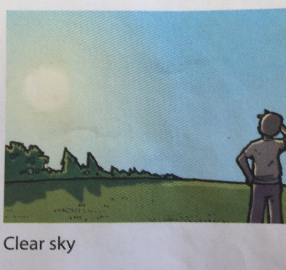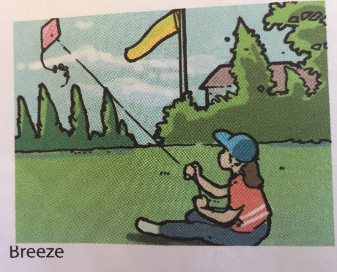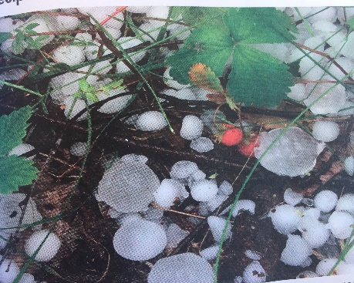
Clear sky Breeze Precipitation

