Week 8.

Before you start this new section leave a page.

I have activities on Mixtures and water resources: Water pollution.

You can print and paste the work in your workbook or you can rewrite the work in your workbook.

The choice is yours.

Keep safe.

Mr. Debipersad and Mrs. Komane

__________________________________________________________________________________

Please click on the links below to watch videos on water pollution. [https://www.youtube.com/watch?list=RDCMUCVLajedX43G0E1BRVx7Q7dQ&v=71IBbTy- _n4&feature=emb_rel_end](https://www.youtube.com/watch?list=RDCMUCVLajedX43G0E1BRVx7Q7dQ&v=71IBbTy-%20%20_n4&feature=emb_rel_end)

<https://www.youtube.com/watch?v=XMWFOBXhKjk>

<https://www.youtube.com/watch?v=DHlFxMq9VYo>

Activity 1:

Study the pictures below and then answer the questions that follow.

 

*Pollution in a pond A polluted river.*

 **

*Pollution on the coast People have been using this stream to dump rubbish.*



Oil spill

QUESTIONS:

1. Look at the pictures above and make a list of all the objects that do not belong in the water.

_______________________________________________________________________________

_______________________________________________________________________________

2. What are the three main categories of pollutants found in water?

_____________________________________________________

_____________________________________________________

_____________________________________________________

3. Which category of pollutants would you be able to see with the naked eye?

_______________________________________________________________________________

4. Which categories of pollutants would you not be able to see with the naked eye?

_______________________________________________________________________________

5. How do you think insoluble pollutants end up in water?

______________________________________________________________________________________________________________________________________________________________

6. How do you think soluble pollutants end up in water?

______________________________________________________________________________________________________________________________________________________________

7. How do you think bacteria that cause illness like diarrhoea and cholera end up in water?

______________________________________________________________________________________________________________________________________________________________

8. How do you think oil ends up in the water, especially in oceans?

______________________________________________________________________________________________________________________________________________________________

9. What do all 3 categories of pollutants have in common?

_______________________________________________________________________________

Mixtures and water resources: Water Pollution

**What is water pollution?**

Water pollution happens when toxic substances enter water bodies such as lakes, rivers and oceans, getting dissolved in them, lying suspended in the water or depositing things on the bed. This degrades the quality of water. The water is not safe for healthy for living things. Not only does this spell disaster for aquatic ecosystems, the pollutants also seep through and reach the groundwater, which might end up in our households as contaminated water which we use in our daily activities, including drinking.

**Causes of water pollution:**

* Insoluble substances such as oil and plastic.

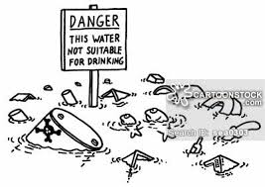 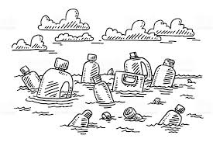

* Soluble substances such as soaps and fertilizers.

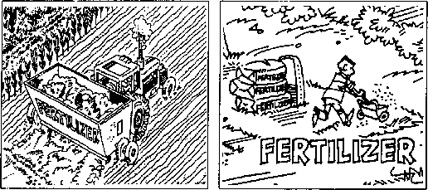

* Germs from toilet waste.

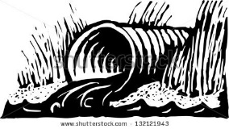

**Water pollution by soluble substance.**

Waste like soaps, fertilisers, insecticides and acids will dissolve into the water and will change the chemistry of the water.

Soaps and fertilisers decrease the level of oxygen in the water. This polluted water will kill plants, animals and fish because of the lower oxygen levels in the water.

Metals and dissolved chemicals such as acid pollute lakes and rivers. The chemicals are poisonous to many forms of water life and also to humans. Lead from mining waste and paint contaminate the water. If we drink this contaminated water, it can cause damage to the brain and kidneys. Lead and other harmful chemicals can get into our food if we water crops with the polluted water.

**Water pollution by living germs:**

Toilet waste pollutes water when people use rivers and streams as a toilet or if they put their toilet waste into the water. Germs in the water can make people sick with diseases such as cholera and diarrhoea. If someone drinks this water or uses it to wash food, they may get water-borne diseases. People can die from these diseases.

Cholera is a more serious type of diarrhoea. It is caused by a germ found mainly in water polluted with faeces.

Activity 2: Read pages 92, 93 and 94 in your NSTECH textbook and then answer the questions that follow.

**Water pollution by insoluble substances:**

1.Name some insoluble substances that cause water pollution.

____________________________________________________________________________________________________________________________________________________________________

2. Explain how water is polluted by oil.

_____________________________________________________________________________________________________________________________________________________________________________________________________________________________________________________________________

3. Explain how water is polluted by plastic.

_____________________________________________________________________________________________________________________________________________________________________________________________________________________________________________________________________4. Explain how water is polluted by humans.

____________________________________________________________________________________________________________________________________________________________________________________________________________________________________________________________________________________________________________________________________________________________

Complete activity 2 on page 95. Explain the effects of water pollution.