TERM 2: WEEK 1 -2 VISUAL ARTS GRADE 4

Good day learners please read your Rubric and start your Art Assessments at home. Kind Regards Mrs Wilson
GRADE 4: Cut out your favourite things in life from magazines or print out from the internet. E.g. food, colour, toys, family, pets, cartoons, video games, friends, sport, movies and favourite books. Also cut out different words and lettering as well.
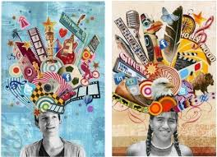

ASSESSMENT RUBRIC: VISUAL ARTS: TERM 2 GRADE 4
EDENGLEN PRIMARY SCHOOL
Topic / Skill: “Self-portrait” Making a mixed media poster using lettering, pattern making and collage.
Name and surname: ______________________________________ Mark 40 /_____
Rubric: Self-portrait | 0 – 4 Limited | 5 – 6  Adequate | 6 – 7  Proficient | 8 – 10  Excellent
- Learner used all the art elements in his/her colour pencil drawing of their face.
- Learner cut out pictures of themselves and their favourite thing in life.
- Learner used interesting mixed media, lettering and pattern making in their poster.
- Overall appearance of self-portrait using all the techniques taught.

