Grade 5 – Life Skills – Performing Arts Topic: Become a character Page 124
Week 15: (6 July 2020 – 10 July 2020)
- Please print this page and paste in your book.
- Complete the questions on the printed paper.
Introduction
When we move our bodies it is important to have co-ordination and control. Control is being able to hold your body steady and to get your body to do what you would like it to do.
You have to have control over your entire body to perform difficult activities such as hand stands, cartwheels, juggling or skipping rope.
Role-play a character
To role-play is when you take on the role of a character, or pretend to be someone else. A character is who an actor is pretending to be in a play. When you role-play, you can pretend to be someone and feel what it might be like to be them.
Use your textbook Page 124 and explain the following:
- Write down the meaning of the following key words:

Co-ordination: __________________________________________________________________
_______________________________________________________________________________
Role-play: ______________________________________________________________________
_______________________________________________________________________________
Character: ______________________________________________________________________
_______________________________________________________________________________
- Look at the picture on Page 124 of the man that juggles. Explain how he does this.
_______________________________________________________________________________
_______________________________________________________________________________
- Explain what control means.
_______________________________________________________________________________
_______________________________________________________________________________
- Explain how you need to use control to perform difficult activities.
_______________________________________________________________________________
_______________________________________________________________________________
_______________________________________________________________________________
- Give examples of difficult activities.
____________________________________ ____________________________________
____________________________________ ____________________________________
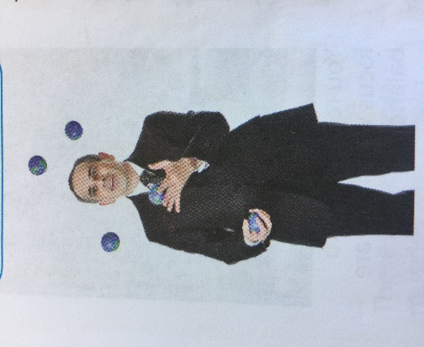
Juggles

